K.P.C. PUBLIC SCHOOL, KHARGHAR
Assessment lV 2022-2023

GRADE: VII MARKS: 50
SUB: MATHS TIME: 2 HRS
Q1: CHOOSE THE CORRECT ANSWER: 6M
- The coefficient of xy in 12xyz + 15 is _______.
a. 12 b. 12z c. 12xy d. 15
- 4x + 9 = 17 is a _____.
a. Linear equation b. Linear equation in one variable
c. Equation in one variable d. None of these
- If for ∆ABC and ∆DEF, the correspondence CAB ⟷ EDF gives a congruence, then which of the following
statement is correct?
a. AB = DF b. AB = EF c. ∠A = ∠F d. BC = DF
- What cross section will we get if a spherical ball is cut horizontally?
a. Square b. Semicircle c. Circle d. Rectangle
- Which among the following is an inequation?
a. 1069x + 10y = 15z b. 6x – 6 = 10 c. x² + 5 = 21 d. 5p + z < 0
- Identify the type of expression: 100m +150n – 50p – 100mn
a. Monomial b. Binomial c. Trinomial d. Polynomial
Q2: SOLVE THE FOLLOWING: 8M
- a. Add: –10xy and 4xy
b. Subtract: 9x²pz from 18px²z
- Convert the following statement into equation and solve:
Thrice a number when increase by 6 gives 24
- If ∆ABC and ∆PQR in the adjoining figure are to be congruent, name one additional pair of corresponding parts. Which criterion did you use?
- Match the solids with their nets:

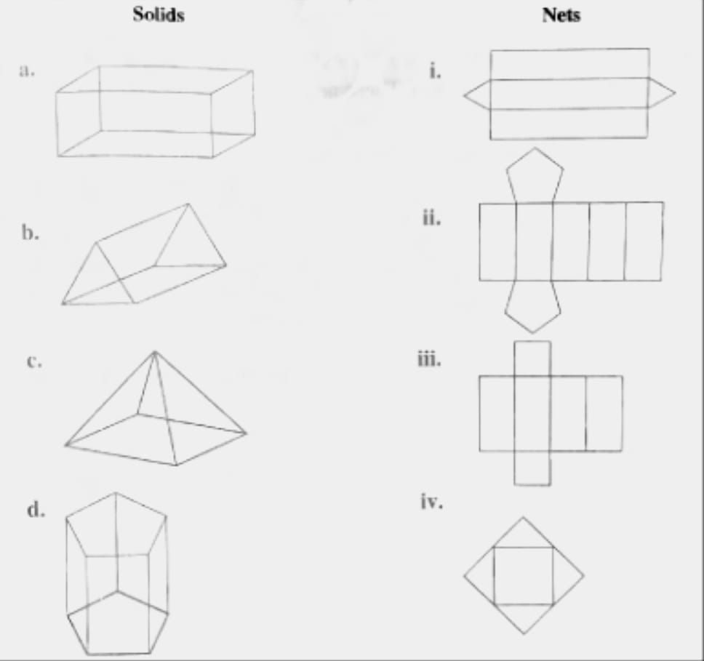

Q3: EVALUATE THE FOLLOWING: [Any 3] 9M
- Simplify (3x + 2y - 9) + (2x - 6y + 2) - [(4x - 9y - 1) + (- 3x + 8y + 7)]
- Solve $\frac{3x}{2}-20=\frac{5}{2}$
- State the correspondence between vertices, sides and angles of ∆ABC ≅ ∆PRQ
- Write the number of vertices, edges and faces in the following:
- Cylinder b. Triangular pyramid
Q4: EVALUATE THE FOLLOWING: [Any 3] 12M
- If P=17x³+ 15x² - 7x+9, Q= - 10x³ - 5x² + 2x + 1 and R = 11x³ - 6x²+5x+10, then find
P + Q - R .
- A number plus two-third of itself, plus one-half of itself plus one-seventh of itself equals 97. Find the number.
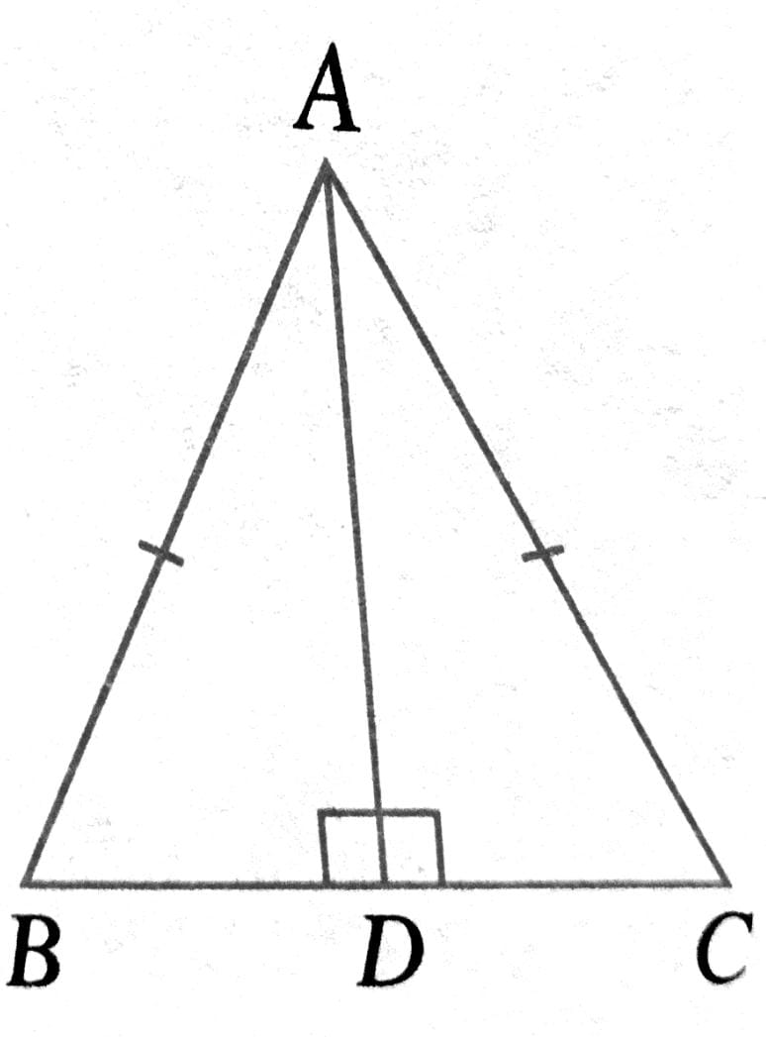
- ∆ABC is an isosceles with AB = AC. AD is the altitude from A
to side BC.
- Is ∆ABD ≅ ∆ACD?
If yes, write the pairs of corresponding parts which
are equal and the congruence criterion.
- Is BD = DC? Why?
- Given below is a net of a cube with numbers 1 to 6 marked on its 6 faces. Form the cube and then answer the following questions.
- Which face is opposite to 3?
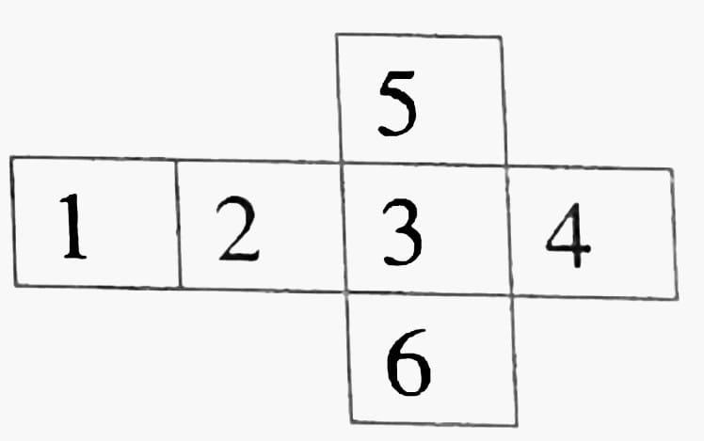
- Which face is opposite to 5?
- Which face is opposite to 2?
- Which faces are adjacent to 6?
- Which faces are adjacent to 1?
- Which faces are adjacent to 4?
- Which faces are adjacent to 1 as well as 6?
- Which faces are adjacent to 2 as well as 4?

Q5: SOLVE THE FOLLOWING: [Any 3] 15M
- Sandra sells sea fish in the market. In the morning, he opened his shop with (15x+20) fish. He sold (x+5) fish in the morning, (3x-10) fish in the afternoon and (10x-5) fish in the evening. How many fish are left with him at the end of the day?

- A man spends one-third of his monthly income on food, one-fourth on children's education and one-sixth on household expenses. He keeps the remaining Rs.7000 for savings. What is his monthly income?

- Subtract the sum of 6m + 5n - 7p² and 6p² - 2m+ n from the sum of 2m + 3n - 10p²
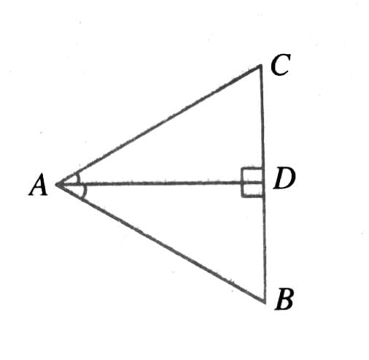
and – m - 2n - 3p²
- In the adjoining figure, AD bisects ∠A and AD ⟂ BC.

  - Is ∆ADB ≅ ∆ADC? Why?
  - Is BD = DC? Why?
  - Is ∠C=∠B? Why?

